“Get Along, Shakespeare” at RRCC
Posted: 03/27/2008
Author: Elizabeth Parks

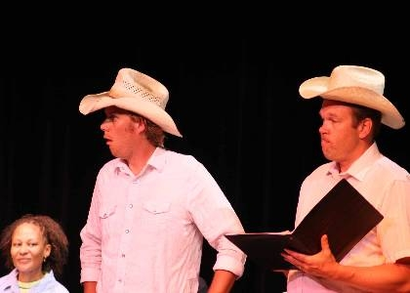

World Premiere: Git Along, Shakespeare
Opens April 11, 2008

Red Rocks Community College Theatre presents an original two-part production celebrating American western culture and the early American Theatre with Git Along, Shakespeare. The production will feature the world premiere of A Midsummer Night's Western by August Mergelman, followed and an old fashioned 19 th century Olio show including song, dance and dramatic recitations from the turn of the century.

Git Along, Shakespeare will perform April 11-27, 2008 in the Red Rocks Community College Theatre at Red Rocks Community College. A Midsummer Night's Western, which opens the production, brings the creative mind of playwright August Mergelman to the public as the play provides a western twist on Shakespeare's A Midsummer Nights Dream. The play received its first staged reading this summer at the 2007 Playwrights Showcase of the Western Region. As a direct result of the Playwrights Showcase, the play's production and upcoming publication by Pioneer Drama Services, Inc. give hope to all aspiring playwrights and prove the fruitfulness and necessity of such conferences.

Mergelman's play is followed by a marvelously staged 19 th century variety show, or”olio" as it was originally termed. Olio, meaning miscellany, will be just that, a masterful miscellany of theatrical delights that celebrate the glory of the early American stage. A ten-gallon tale and much, much more; Git Along, Shakespeare is pure family entertainment that is sure to delight audiences of all ages. Git Along, Shakespeare will perform on Friday and Saturday nights April 11, 12, 18, 19, 25 and 26 at 7:30 p.m. with one Sunday matinee on April 27 at 2:00 p.m.

Tickets are $10 for adults, $9 for seniors and $8 for students. RRCC Students, with current ID, may obtain a voucher from RRCC Student Life to gain free admission. Reservations may be made by calling 303-914-6458. All performances will be held in the Red Rocks Community College Theatre, located at the west end of the main campus building, downstairs. RRCC is located at 13300 W. 6th Ave in Lakewood (on the 6 th Avenue Frontage Road between the Union and Indiana exits).

For more information, and reservations contact Elizabeth Parks at 303-914-6458 or email Elizabeth at
elizabeth.parks@rrcc.edu

